I B. Tech. I Semester Regular Examinations – January, 2023
ELEMENTARY MATHEMATICS
Time: 150 Min (bi/BIO-TECH/BME/FT) Max. Marks:80M

SECTION – A
Answer All the questions 4X10M=40M
- After a knee surgery, your trainer tells you return to your jogging program slowly. He suggests jogging for 12 minutes each day for the first week. Each week thereafter, he suggests that you increase that time by 6 minutes per day. How many weeks will it be before you are up to jogging 60 minutes per day?

- What are the different types in partial fractions? Decompose the expression 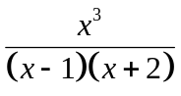 into partial fractions.

- Find the derivatives of the following functions from first principle :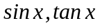.

- Draw the rough sketch of parabolas 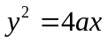 and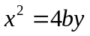. Do you find any common area between these graphs? If so, determine the common area by using definite integration.

Answer All the questions 2X20M=40M
- Prove the following two identities, using appropriate trigonometric identities:
- 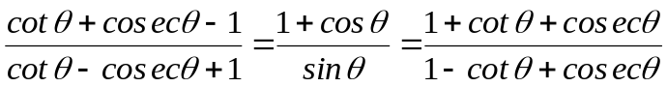

- Write the different methods of solving the integrations. Can you identify an appropriate method to solve the following function and hence integrate them?
- 
 